# Data Polish Dashboard

Welcome to the Data Polish Dashboard, an intuitive interface for data management and exploration. The dashboard is organized into three distinct sections:

**Data Profile**: Here, you can understand the structure and composition of your data.

**Data Quality:** This section is dedicated to evaluating the quality of your data, helping ensure accuracy and reliability.

**Data Exploration:** Explore and interact with your data in various ways to gain deeper insights.

## Navigating the Dashboard:

Easily navigate between these sections using the three tabs located at the top of the dashboard.

The tab you are currently viewing will be distinctly marked with a purple underline for easy identification.

Use these tabs to effortlessly switch between different aspects of your data, enhancing your data management experience.

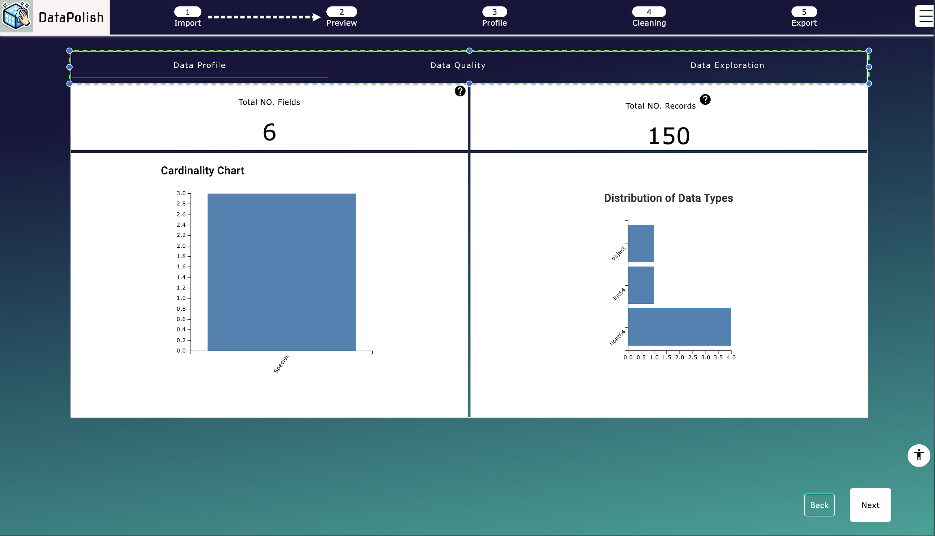

## Data Profile Tab

### Overview:

The Data Profile helps you understand the fundamental structure of your data. It's designed to provide an overview of your data.

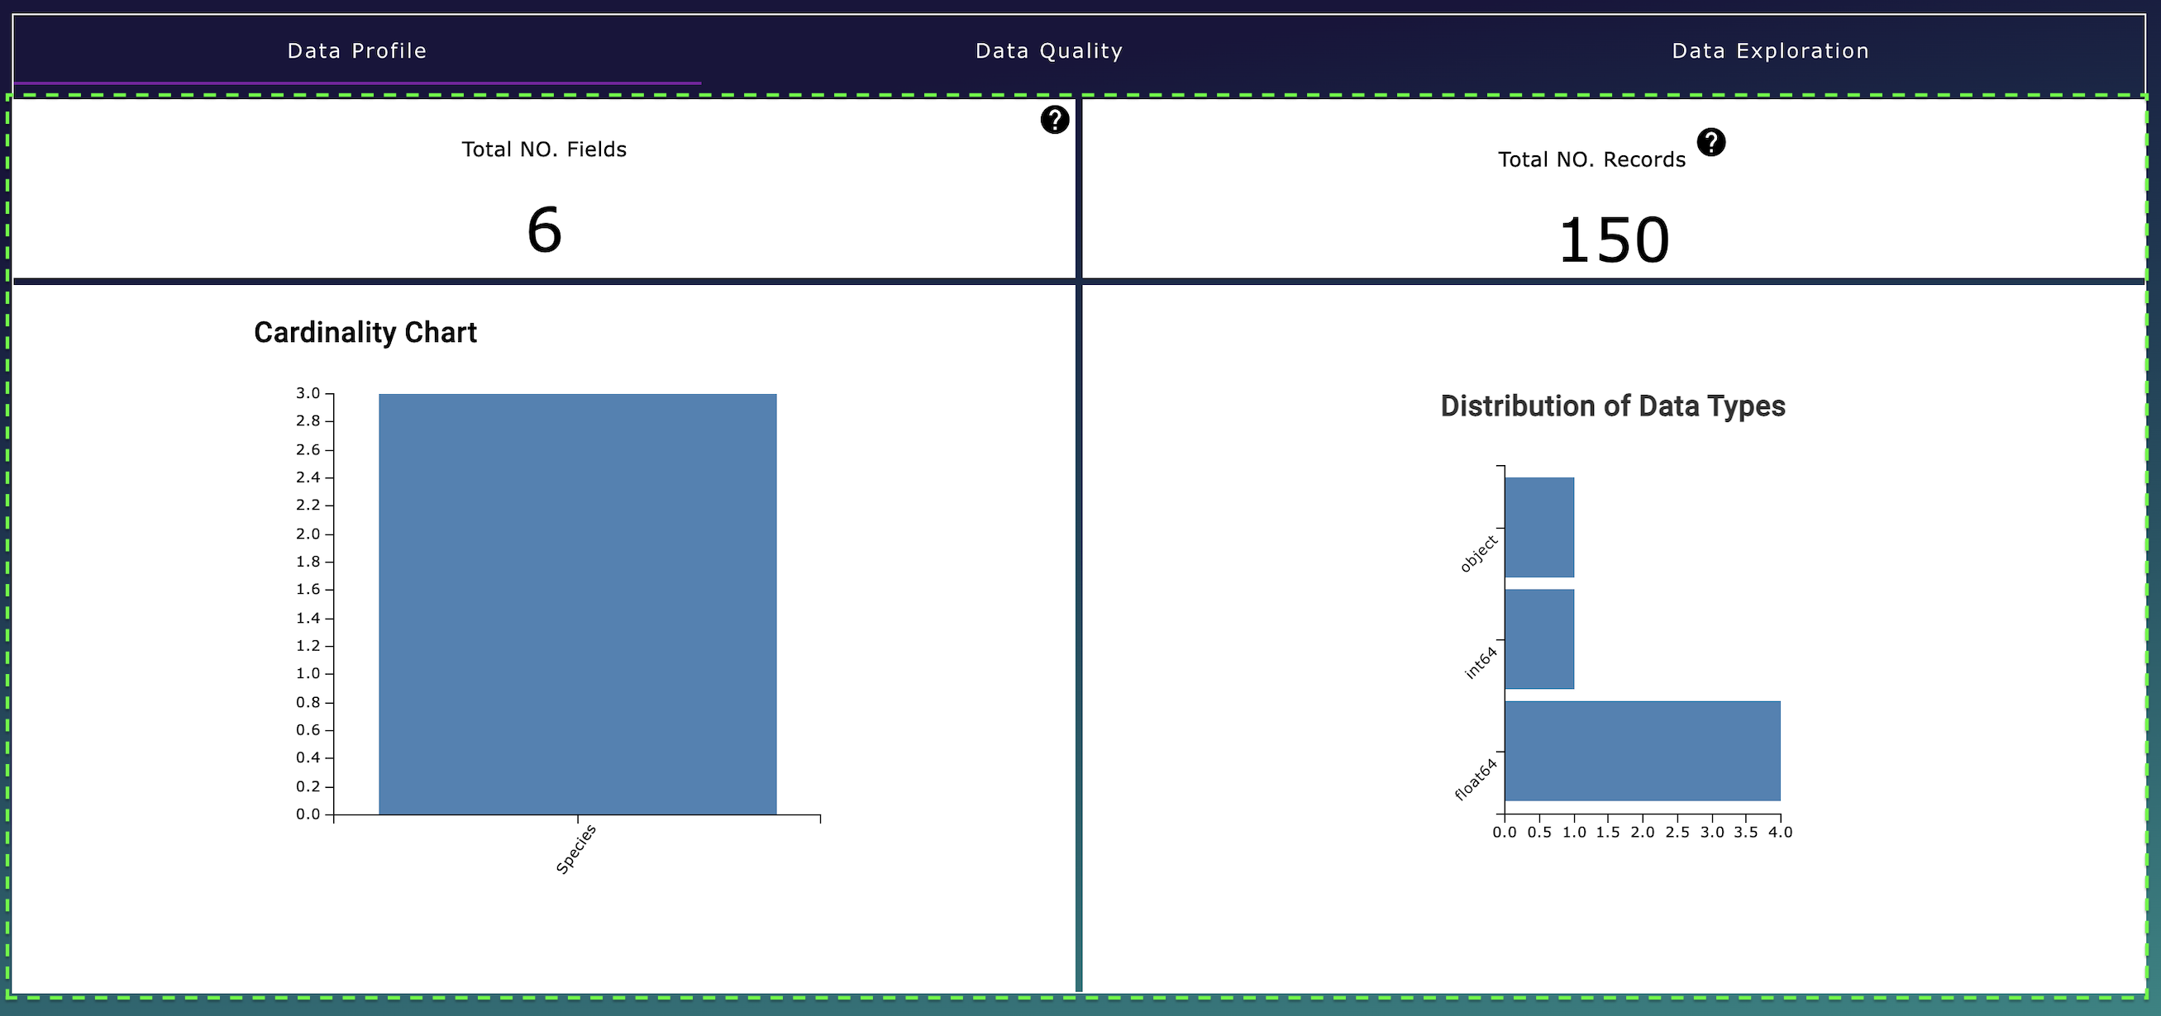

### Key Features:

**Record Count:** View the total number of records in your dataset.

**Field Count:** View the total number of fields, providing a glimpse into the dataset's complexity.

**Cardinality of Text Fields:** Understand the uniqueness of text data by exploring the cardinality, indicating the diversity in text fields.

**Data Type Distribution:** Examine the distribution of data types within your dataset. This feature helps in understanding the proportion of different data types like numeric, text, dates, etc.

### Visual Insights:

Below, you'll find a series of charts that visually represent these data attributes. These charts are designed to offer a clear and immediate understanding of your data's structure and composition.

Use the Data Profile tab to gain a deep and immediate understanding of the structure and nature of your data, setting the foundation for further data quality and exploration activities.

## Data Quality tab:

### Overview

The Data Quality tab is designed to provide you with an understanding of the quality of your data. This tab is a powerful tool for identifying and addressing data quality issues.

### Key Features:

**Duplicate Record Identification:** Discover the number of duplicate records in your dataset.

**Data Quality Score:** Gives you a summarized view of your data's quality through a comprehensive score. This score is a quick indicator of the overall health of your data.

**Missing Values Chart:** Easily identify fields with missing values and quantify the extent of these gaps in your data.

### Data Quality Score Attributes:

The Data Quality Score is broken down into four key attributes, each representing an aspect of data quality:

**Completeness**: Assessing whether all necessary data fields are filled.

**Uniqueness**: Evaluating the exclusivity of data entries.

**Consistency**: Ensuring that data formats and values are uniform across the dataset.

**Readability**: Determining the ease with which data can be read and understood by users and processing systems:

View these attributes in detail using the radar chart, providing a visual representation of your data’s strengths and areas for improvement.

Alternatively, click 'Expand' under the Data Quality score metric for a more detailed breakdown, as illustrated below.

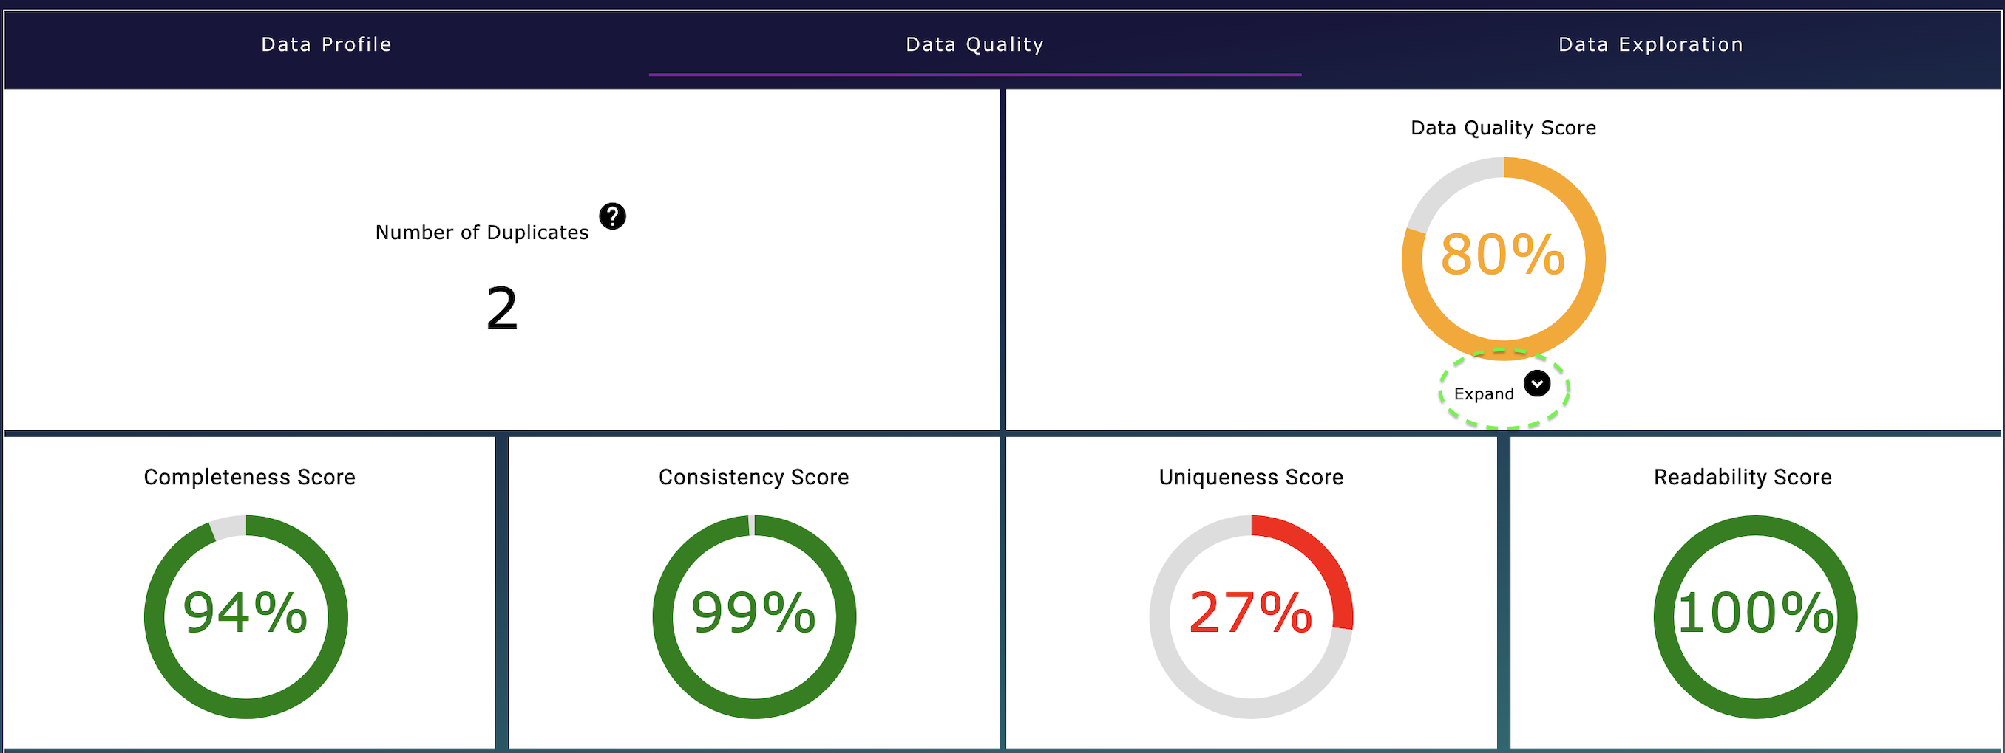

Data Exploration tab